**Department of Computer Science, Namal University, Mianwali**

**Submission deadline: *16th June 2025***

**Presentation: *First Week of June***

**Checklist for PAS Project Report**

**Font/Size: Time New Roman / 12**

**Insert Page numbers**

1. **Title page:**
2. Topic Name
3. Student name and registration number
4. **Table of contents**
5. **Introduction:**
6. A one-paragraph brief literature review
7. Data sets should be organized into ordered pairs and provide a description of the data and variables used.
8. Tools used in the project (like python, excel or any other)
9. **Project Statement (3-4 lines)**
10. **Purpose (3-4 lines):**
11. What motivated you to take on this project? What is done?
12. The direction it takes on, aims towards, or possesses?
13. Application and significance of your problem-related statistics
14. **Data Analysis** (This section contains all statistics including mean, mode, median, quartiles, percentiles, variance, standard deviations, approximately normal histogram, and correlation coefficients)
15. **Results/Graphs** (Four paragraphs should ideally fit on a single page, each with a paragraph reference and one-line description.)
16. **Conclusion** (**5-6 lines** or one paragraph related to your project findings etc., future suggestions for the improvement)
17. **References** (Minimum **2-3**)

**Reference structure and example: Harvard Style**

Author Surname, Initials. (Publication Year) Title. Place of Publication: Publisher.

Ozeki, R. (2013) *A tale for the time being*. New York: Penguin Books.

*Note: You may take help from google scholar*

*Link:*

*https://scholar.google.com/scholar?hl=en&as_sdt=0%2C5&q=Ozeki%2C+R.+%282013%29+A+tale+for+the+time+being.+New+York%3A+Penguin+Books.+&btnG=#d=gs_cit&t=1684136513487&u=%2Fscholar%3Fq%3Dinfo%3AGHuun0ILQGgJ%3Ascholar.google.com%2F%26output%3Dcite%26scirp%3D0%26hl%3Den*

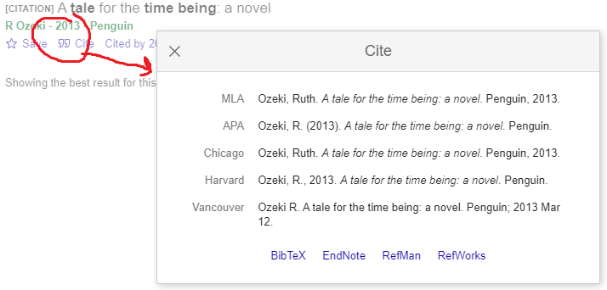

Anticipating the best project!

**Good Luck** ☺